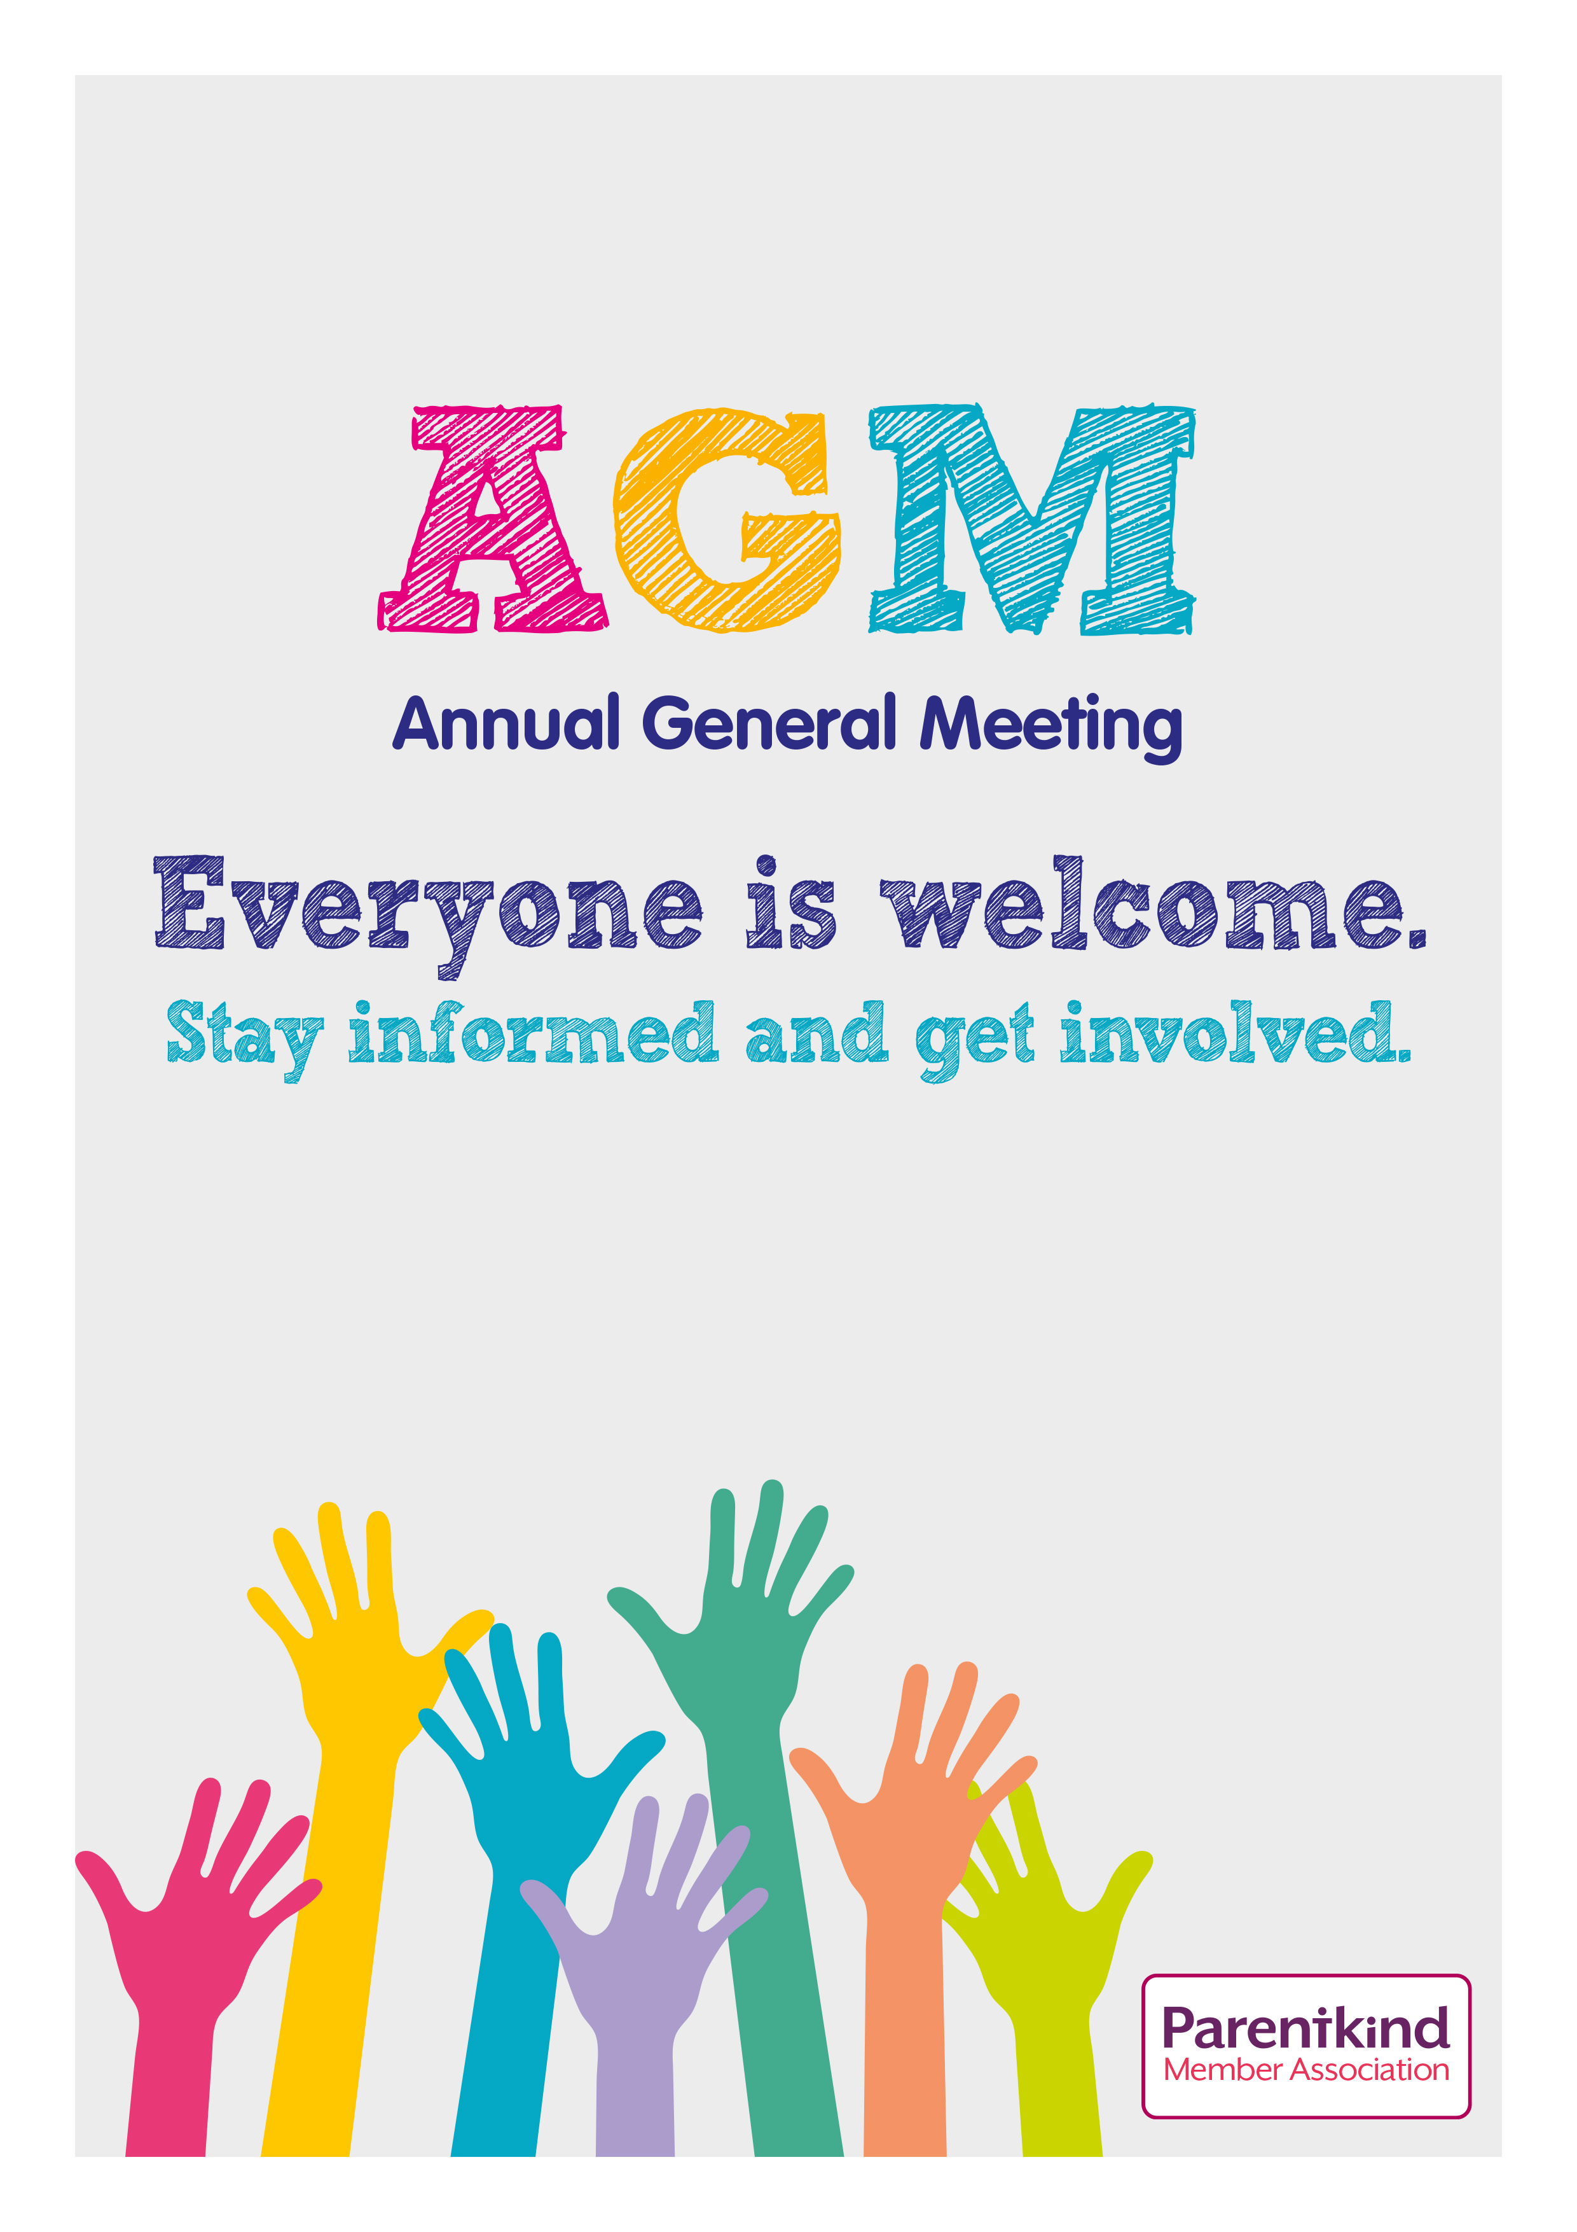
Wednesday 19th November
7pm in the Staff room
South Hykeham Friends of the School

