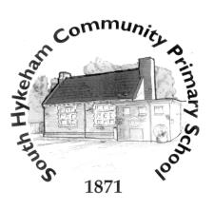
Writing Genres Recount
Non-chronological reports
Narrative writing.

Overarching question: How can we identify and sort rocks based on their properties?
Lines of enquiry:
1.How can we sort rocks?
2. What are the properties of different rocks?
3. What rocks are present in the local area?
4.What is a fossil?
5. How are fossils formed?
D.T.
How can I create a shell structure to package a food product?
Exploring shell structures.

Overarching question: What is the Trinity?
What is the symbolism of water?
What is the difference between a gospel and a letter in the Bible?
Why do baptisms include references to the Trinity?
Can you make links using Bible texts about what God is like for Christians?
How do Christians show their beliefs about God and the Trinity in prayer and in the way they live?
R.E.

P.S.H.E.
Dreams and goals/Healthy me.
Computing
Using emails/Journey inside a computer

History
Overarching question: Why did the Romans come to Britain and what did they do for Lincoln?
Lines of enquiry:
1. Who were the Romans?
2. When did the Romans invade Britain and why?
3. Did everyone welcome the Romans to Britain?
4. Why did the Romans come to Lincoln?
5. What are the Roman features/buildings in Lincoln?
6. What did the Romans do for Lincoln?

French

1. French names
2.Colours
3.Opinions
4.Word order of adjectives
5.A traditional story: the Enormous turnip

6.Numbers 1-10
7.French maths:addition and subtraction
8.J’ai (I have)
9.Age
10.Easter

Overarching question: What is a balanced diet and why is it important?
Lines of enquiry:
1.What are the names of the 5 food groups?
2.What happens when you have too little or too much of a food group?
3.What is a balanced diet?
4.How is a pescatarian diet similar or different to a vegan or vegetarian diet?
5.What are the differences between a carnivore, omnivore and herbivore diet?
Geography
Overarching question: How do rivers, mountains and coasts shape our land?
Lines of enquiry:
1. What are the main rivers and seas of the UK?
2. What is a mountain and how are they formed?
3. Where are areas of high ground in the U.K.
4. What is the journey of a river?
5. What is a four figure grid reference?
6. What are the features of a coast?

P.E.
Dance/Net/wall games (tennis & Volleyball

English

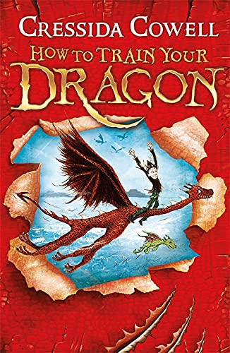
Maths
Number and Place Value
Addition and Subtraction
Measurement (money, time, length & perimeter)
Geometry
Multiplication and Division
Fractions
Statistics

Art
How can I tell a story through mosaics.
Learning where mosaics originated from and then develop the skills to make a mosaic.
Year 3
Spring Term 2026
Music
Let your spirit fly
Glockenspiel

Science

