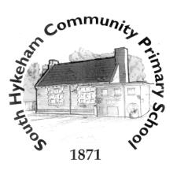
Writing Genres Recount
Non-chronological reports
Narrative writing.

Art
How can I create a face portrait out of clay?
How do I sketch a face portrait?
How do I show facial expressions in portraits?
How do I create different skin tones?
How do I use moulding and joining techniques to make a clay face?
How do I create skin tones on a clay sculpture?
How effective is my clay face?

D.T.
Cooking & nutrition
Healthy diet.

A traditional story: the Enormous turnip
Numbers 1-10
French maths:addition and subtraction
J’ai (I have)
Age
Definite (le,la,les) and indefinite (un, une, des) articles

Je voudrais (I would like) ·
Extending sentences with mais · C’est · Extending sentences with aussi ·
Numbers 1-15
Days of the week

French

History
Completing Romans topic then ….
What happened after the Romans left Britain? (A Saxon Viking overview)
Why, where and when did the Scots and Anglo-Saxons invaded Britain?
How have the Anglo Saxons influenced place names today?
What was life like in an Anglo-Saxon village?
What do artefacts tell us about the past?
Who were the Vikings and where did they come from?
What was the Danelaw?

R.E.
Why do Christians call the day Jesus died Good Friday?
What is Salvation?
What happened to Jesus at Easter?
What do different Christian groups do during Holy Week?
How do people feel about each day of Holy Week?
Why did Jesus wash his disciples’ feet?
What does it mean to live a good life?
What texts do Christians read to support them in living a ‘good life’?
How do Christians live out the teachings from the Bible?
What texts do Muslims read to support them in living a ‘good life’?
How do Muslims live out the teachings from the Qu’ran?

Computing
Creating Media: Video Trailers
Databases: Comparison Cards

P.S.H.E.
Relationships
Changing me.
Maths
Number and Place Value
Addition and Subtraction
Measurement ( time, money, volume & capacity)
Geometry (angles & turns)
Multiplication and Division
Fractions (equivalence)
Statistics

English

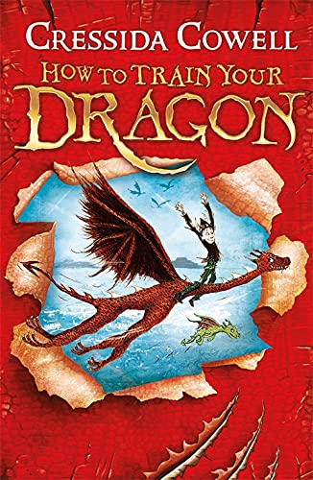
P.E.
Games- Athletics
Striking & fielding - Rounders

Music
Bringing us together.
Reflect, rewind, replay

Year 3
Summer Term 2026
Science

What are the parts of a plant and how do they function?
What are the different parts of a plant?
Does the number of seeds in a pot affect the growth?
Which parts of the plant receive water from the stem?
What are the best conditions for seeds to grow?
What is pollination?
What is seed dispersal and how does it happen?
Animals - skeletons & muscles.
Where are the skull, femur, pelvis, spine and ribcage in the body?
Why do we have a skeleton?
Do all mammals, amphibians, birds and reptiles have a spine/femur/pelvis/ribcage?
Where is it on the skeleton?
What is an exoskeleton?
Are all animals the same?
What is a joint?
How do we move?

Overarching question: What is a balanced diet and why is it important?
Lines of enquiry:
1.What are the names of the 5 food groups?
2.What happens when you have too little or too much of a food group?
3.What is a balanced diet?
4.How is a pescatarian diet similar or different to a vegan or vegetarian diet?
5.What are the differences between a carnivore, omnivore and herbivore diet?
Geography
What is life like in the Peak District compared to Lincolnshire?
Where is the Peak District and what are its’ features?
What is our local area like to live in?
What are the key features of the Peak District?
Where is Eyam and what can images and maps tell me about it?
What are the similarities and differences between our locality and the Peak District?

